Review questions for Demand and Supply

E17 1. Which of the following affects the supply of a product?
A | price of raw material and wages
B | changes in a consumer’s income
C | availability of substitute products
D | changes in the price consumers are willing to pay

E21 2. Why is the demand for electricity in Clarksville inelastic?

A | because electricity is a necessity
B | because electricity has many close substitutes
C | because electricity does not have any complementary goods
D | because electricity is supplied by several companies in Clarksville  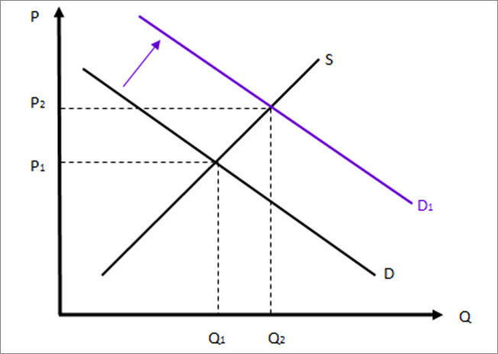  E16 3. Which market condition is shown in the graph above?  A an increase in supply  B a decrease in supply  C an increase in demand  D a decrease in demand  E18 4. Which factors could have caused the change in market conditions shown in the graph above?  A an increase in price  B an increase in population  C an increase in the availability of substitutes  D an increase in the price of a complementary good

E19 5. A government-imposed price control at $60 is a
A | price floor.
B | price ceiling.
C | price shortage.
D | equilibrium price.

E17 6. Mr. Smith had four slices of the “heart attack” pizza at the Blackhorse pub recently. He enjoyed each piece of pizza less than the one he ate just before it. Mr. Smith’s experience at the Blackhorse reflects this economic concept.

A | law of demand
B | real income effect
C | substitution effect
D | law of diminishing marginal utility

E21 7. Which of these products are likely to have inelastic demand?

A | soap, gasoline, eggs
B | fast food, ice cream, vacation
C | Mountain Dew, Dr. Pepper, RC
D | name brand cereal, organic foods, junk food

E11 8. If the price of an item rises, quantity demanded usually

A | falls.
B | rises.
C | remains unchanged.
D | reflects the presence of new suppliers.

E17 9. Which of the following affects the demand of a product?
A | number of firms in an industry
B | increase in population of an area
C | increase in tariffs on the product
D | decrease in taxation on production

