Review guide for Midterm Exam

Unit 1 Scarcity and the introduction to Economics

1.) Name an example for each factor of production (land, labor, capital)

2.) What is scarcity? What two things are always scarce?

3.) “I live in a society where the government provides an apartment, guaranteed retirement, and healthcare, but there are no jobs and we frequently run out of food because all good are controlled by the government.”
This illustrated economic SECURITY in what type of economic system? (market, command, capitalist, traditional)?

4.) While shopping at the mall, Madeline will only buy a pair of jeans if the price is acceptable to her. This transaction represents the economic concept of (socialism, voluntary exchange, factors of production, production possibilities)

5.) “In almost every other race of animals, each individual, when it is grown up to maturity, is entirely independent, and in its natural state has occasion for the assistance of no other living creature. But man has almost constant occasion for the help of his brethren, and it is in vain for him to expect it from their benevolence only. He will be more likely to prevail if he can interest their self-love in his favor, and show them that it is for their own advantage to do for him what he requires of them. Whoever offers to another a bargain of any kind, proposes to do this. Give me that which I want, and you shall have this which you want, is the meaning of every such offer; and it is in this manner that we obtain from one another the far greater part of those good offices which we stand in need of. It is not from the benevolence of the butcher, the brewer, or the baker that we expect our dinner, but from their regard to their own interest.”
-Adam Smith, The Wealth of Nations, Chapter 2

Which statement summarizes Smith’s view of voluntary exchange? (Man will engage in voluntary exchange if it is to his benefit)

6.) What type of economic system is North Korea? (mixed, capitalist, command, free market) because the government CONTROLS ALL FACTORS OF PRODUCTION

7.) 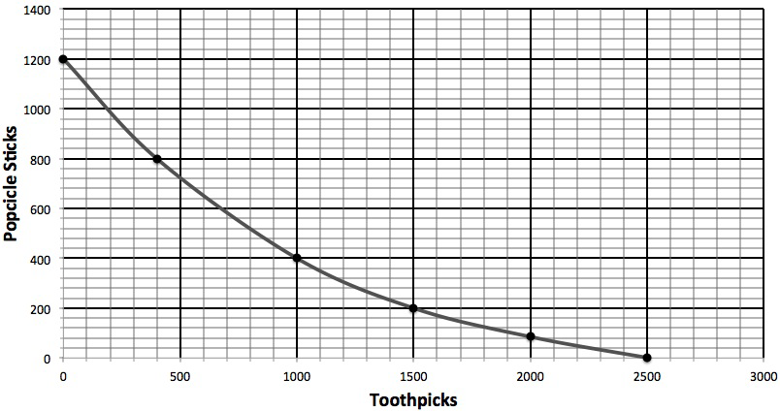
Clarksville Wood Works’ opportunity cost for producing 200 popsicle sticks is how many toothpicks?

8.) What are the goals of the American free enterprise system?

9.) Which of the statements from the article above reflects how the supply for Quinoa is changing?

a. “Quinoa currently fetches as much as $3,200 a ton, up nearly threefold from five years ago.”
b. “It's also gluten-free. Though used like a grain, quinoa is actually an edible seed.”
c. “Bolivia's quinoa crop expanded from 240 square miles (63,000 hectares) in 2009 to 400 square miles (104,000 hectares) last year.”
d. “The growing global demand for quinoa by health food enthusiasts isn't just raising prices for the Andean "super grain" and living standards among Bolivian farmers.”

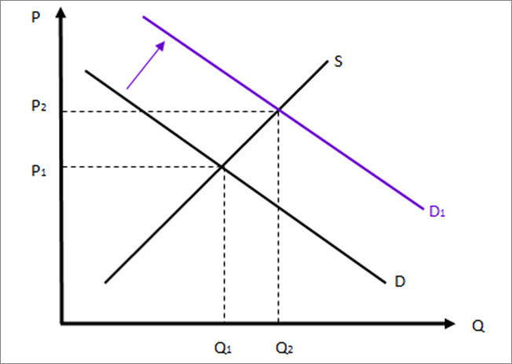

10.) The above graph is showing what market condition? What are the factors that could have caused this shift?

11.) “There is only one boss. The customer. And he can fire everybody in the company from the chairman on down, simply by spending his money somewhere else.” - Sam Walton
The above quote shows what economic concept?

12.) 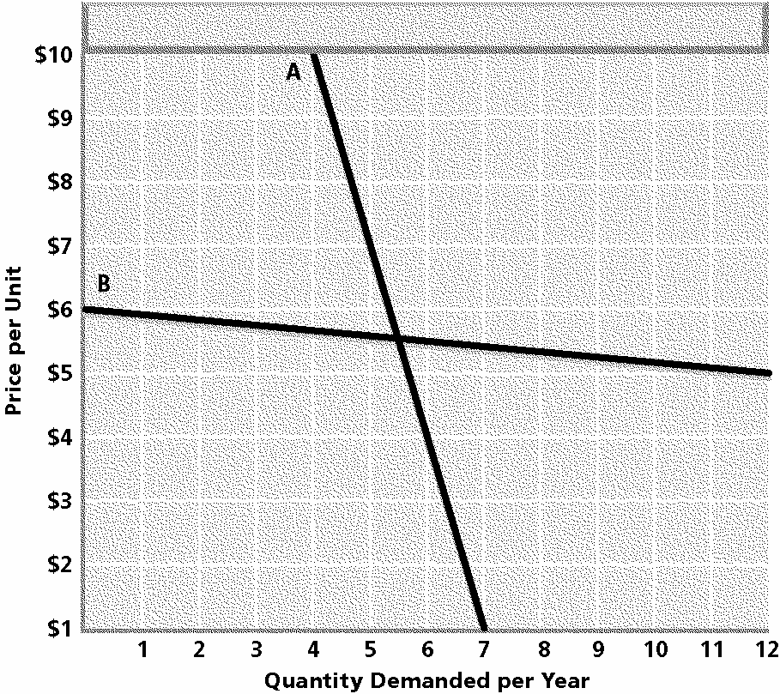

Curve B is elastic or inelastic?

13.) 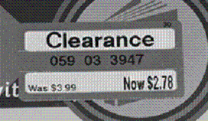
Assume that the price tag shown above is for a pair of socks at Target. Which conclusion can be drawn from the price tag?
a. Target is having a sale on basketball apparel.
b. Wal-Mart has increased the price of similar socks.
c. Demand for these socks has fallen causing a surplus.

14.) What are the 5 factors that affect the demand of a product?

15.) Graph on overhead (understand!)

16.) Graph on overhead about price floor

17.) Sprint, T-Mobile Reportedly OK $32 billion Merger Price
June 5, 2014
Sprint and T-Mobile have come to an agreement over key terms of their long-rumored merger, according to reports citing sources close to the companies. The parent companies of both wireless carriers, SoftBank and Deutsche Telekom, still have details to discuss. But Sprint reportedly has agreed to pay T-Mobile $32 billion, a valuation equivalent to $40 per share, which some analysts say is low for such a large company. U.S. regulators are expected to scrutinize any potential deal merging the nation's third- and fourth-largest wireless carriers.

The text above describes what type of merger?

18.) Describe an example of non price competition

19.) Despite the weak economy, the Obama Administration continued to increase the regulatory burden on American businesses in 2012, adding 25 major regulations that increase regulatory burdens by more than $23.5 billion annually. From the beginning of the Obama Administration through 2012, a staggering 131 major regulations that increase regulatory burdens have been issued, with costs approaching $70 billion a year. While the President has acknowledged the need to rein in regulation, little has been done to address the problem. Instead, it is getting worse.

Congress—which shares much of the blame for excessive regulation—must act to ensure that unnecessary and excessively costly regulations are not imposed on the U.S. economy and consumers. Without decisive action, the costs of red tape will continue to grow, and the economy—and average Americans—will be the victims.

-Source: Red Tape Rising; Regulation in Obama’s First Term
Which statement represents the central idea of the text above?

A | Consumers receive multiple protections under government regulation.
B | Small businesses benefit greatly when the government intervenes in business.
C | Economic growth will be negatively impacted by increased government regulation.
D | Entrepreneurs develop new innovations when the government offers incentives.

20.) Three companies – FedEx, UPS, and the United States Postal Service – dominate the package shipping industry.
What type of market structure is this?

21.)
The union representing flight attendants at American Airlines rejected an offer of arbitration from federal mediators yesterday, assuring the start of a 30-day cooling-off period after which its members will be legally free to strike.

The major issue dividing the two sides is pay. The flight attendants now earn $15,000 to $35,000 a year, the union said. American said that the union’s last proposal would cost the airline $570 million more over six years than its final offer. The union said that the gap was closer to $200 million.

Source: The New York Times, May 31, 2001.

E31 If the union in the passage had accepted the offer of arbitration, how would this affect the outcome of negotiations?

A | The union would give up its right to collective bargaining.
B | Both sides would have to accept the arbitrator’s decision.
C | The arbitrator would suggest a solution, but the two sides would not have to accept it.
D | The union would not get what it wants because the arbitrator works for the government.

22.)
Total  Employees | Cars Washed  Per Hour | Total Revenue  Per Hour | Total Labor Cost  Per Hour
1 | 3 | $30 | $15
2 | 7 | $70 | $30
3 | 10 | $100 | $45
4 | 12 | $120 | $60
5 | 13 | $130 | $75

Johnny works at a car wash that charges $10 per car. He can wash 3 cars per hour by himself. He has friends that are willing to work with him at a wage of $15 per hour. Using marginal analysis, how many workers should the car wash employ?
29. The restaurant market is an example of monopolistic competition. There are at least three new restaurants under construction on Wilma Rudolph Boulevard. The construction of these new restaurants is evidence of which characteristic of monopolistic competition?

A | low barriers to entry
B | complete price control
C | sale of identical products

