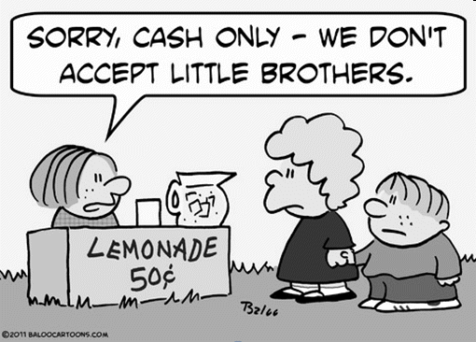

E49 1. The cartoon reflects the use of money as a

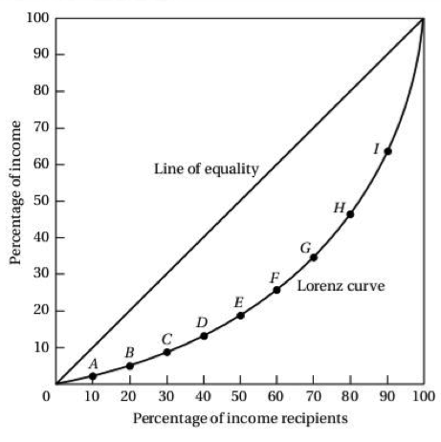

E50 2. According to the graph above, the poorest 50% of income recipients earn approximately what percent of the income in this nation?

E51 3. Know the definitions of M0, M1, and M2. Which one includes near monies?

E53 4. What are the 6 functions of the Federal Reserve?

E49 5. Which function of money are we using when we compare the prices of different products in a store?

E50 6. Which curve is used to express the income inequality in a nation?

E52 7. What is a plausible incentive for consumers to put their money in a financial institution?

8. What statistic best shows cost of living?

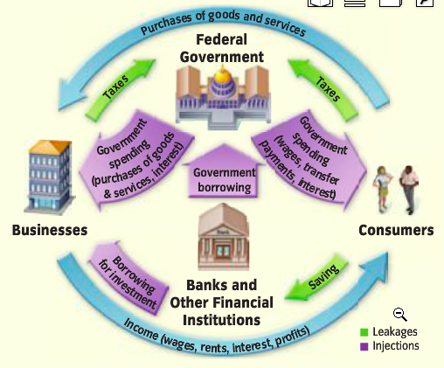

E52 9. According to the graphic above, what role do banks play in the economy of the United States?

Because Russian currency is not trusted, real money plays a fairly small part in Russia’s economy today. Most business is conducted by barter or with IOUs. For example, workers rarely receive wages in the form of cash. A bicycle factory outside the city of Perm pays its workers in bicycles! To get cash, the workers have to sell their “paychecks.” More often than not, they simply trade the bicycles for the products they want.

E49 10. According to the passage, most business in Russia is conducted without currency because Russian currency is not
A | scarce.
B | divisible.
C | portable.
D | accepted.

11. GDP is calculated by summing up what? Aka, what is GDP? Be able to calculate GDP.
12. Which group of people is negatively impacted by an unexpected increase in inflation the most?

13. Know the difference between disinflation and deflation.

14. Understand the business cycle and that war typically increases GDP and production.

15. Define cost-push inflation and demand-pull inflation.

E43 16. Headline: Whirlpool Factory Relocates from Nashville to Mexico. The economic event described in the headline created which type of unemployment in Nashville?

17. Define cyclical unemployment

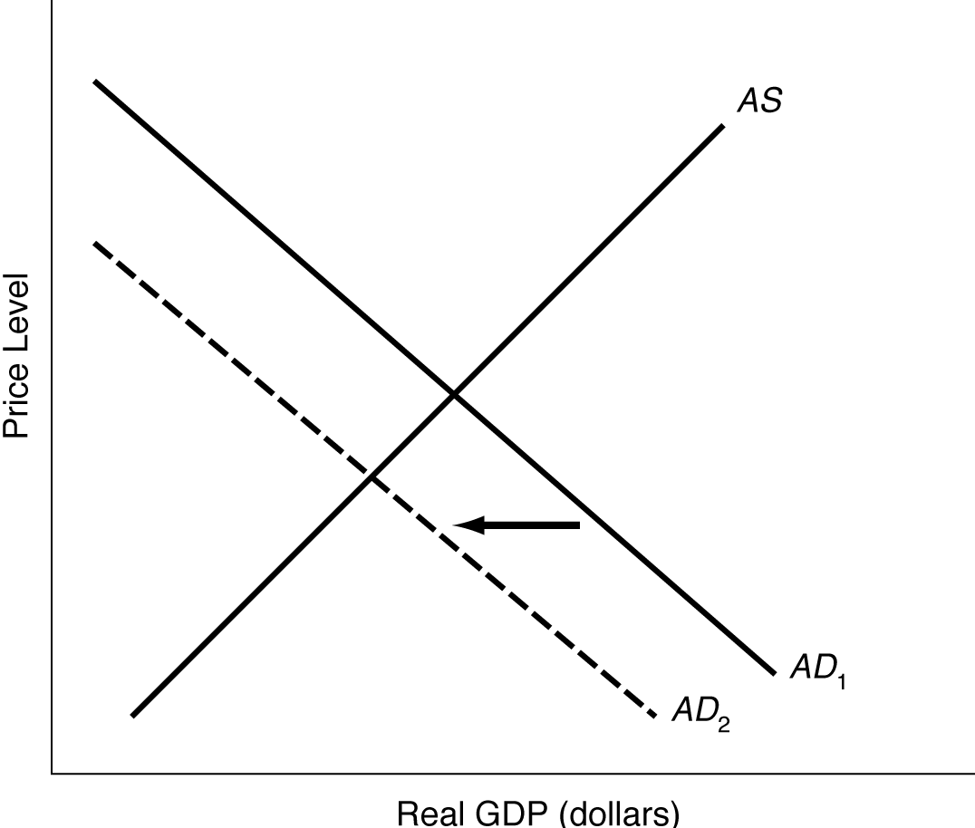 E48 18. What conclusion can be made about this nation’s economy
E48 19. The shift in Aggregate Demand shown above could have been caused by _________________?

E41 20. If the economy is slipping into a recession, what would be an appropriate fiscal policy to use?

21. Define progressive and proportional taxes.
22. What type of tax structure does Tennessee have?
E33 23. What are public good? List two.

E40 24. Which economist believed that the government should borrow and spend to stimulate aggregate demand in order to avoid or shorten economic recessions?

25. If the New York Federal Reserve Bank sells U.S. securities on the open market what effect will it have on the economy?

E34 26. In the United States, the largest source of revenue for local governments is federal income tax.

E33 27. What historic event made people believe that there was a need for more government programs, particularly “safety net” programs for the needy?

E38 28. Social Security began as a “pay-as-you-go” system, meaning that payments to current retirees were paid from whom?
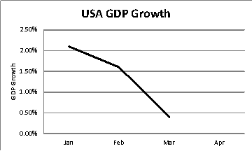

E41 29. Based on the graph shown above, which action is Congress likely to take?

E42 30. Expansionary monetary policy refers to the ____ to increase real GDP.

E40 31. Congress passing a bill that would set aside $500 million dollars to build a new interstate between Denver and Dallas is an example of managing the economy through which policy?

E35 32. A leak from a reactor at a nuclear power plant that causes radiation sickness in several employees would be investigated by which federal agencies (3)?

E54 33. Ideally, when two nations trade, ________.

E54 34. Saudi Arabia should devote its resources to drilling for oil and not on growing food. It can then sell oil to the world and use the money to buy food. This concept is an example of _______.

Country | Opportunity cost of producing bread
Albania | 4 blocks of cheese
Bulgaria | 6 blocks of cheese
Croatia | 2 blocks of cheese
Denmark | 5 blocks of cheese

E55 35. According to the table above, which country should specialize in producing bread for the rest of the world?

E59 36. Which types of jobs are most likely to be outsourced from the United States to foreign factories?

 | United States Merchandise Trade by Area
 | (in billions of dollars)
Area of the World |  | U.S. Imports from | U.S. Exports to
Western Europe |  | $215 | $163
Canada |  | $201 | $167
Japan |  | $131 | $56
Australia, New Zealand, South Africa |  | $10 | $16
OPEC Members (Saudi Arabia, Kuwait, Iran, and others) |  | $42 | $19
 | Source: Economic Report of the President.

E59 37. With which area or areas shown in the table does the United States have a positive trade balance in merchandise?

“It’s been 10 long years since NAFTA was implemented, and the result has been the bleeding of jobs,” [Congressman Ted] Strickland said. . . . In my judgment, we have a trade policy that does not protect American jobs or American companies. . . . And the beneficiaries...are the multinational corporations [whose] only concern is how to increase the bottom line.”. . .

“These companies have gone down there and built modern factories,” Strickland said. “They pay pathetic wages . . . and within sight of those factories, people who work in those factories [are] living in the most pathetic squalor. . . . The jobs going to Mexico haven’t really benefited the Mexican workers. . . .”

Source: Adapted from Jeff Hibbs, “Strickland, Democrats Take Aim on NAFTA,” Wilmington News Journal, November 14, 2003.

E61 38. According to the passage, Congressman Strickland believes that NAFTA has affected American workers in what way?

E55 39. The ability of one country, using the same quantity of resources as another country, to produce a specific product at a lower cost is known as

E60 40. Depreciation of the Japanese yen would make Japanese products sold in the United States _______

