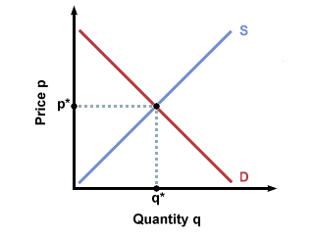

E11, E12, E16, E17, E18 On the graph above, draw a new DEMAND curve to reflect the change described in the article. “Boom in Quinoa…” Identify the NEW equilibrium price and label it P2. Identify the new equilibrium quantity and label it Q2.
Explain how the price of quinoa has changed by referring to your graphs. Is your analysis correct? Support your answer in one complete paragraph that incorporates evidence from the text.

E16, E17, E18, E19 Assume that the government wanted to keep the price for quinoa below the equilibrium price. Identify the type of price control that government would use and draw it on the graph below. Also identify the market condition (surplus or shortage) that this price control would cause. Explain why this market condition would occur.

