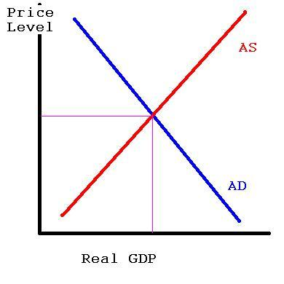
Use the graphic below to answer the following questions.

- How will the price level change if Aggregate Demand increases?

- How does economic output change if Aggregate Demand increases?

- How does unemployment change if Aggregate Demand increases?

- Explain the reasoning you used to answer the previous question.

- Is the change you described your answer to Question 1 demand-pull inflation or cost-push inflation?

- What is the term used to describe the change in prices if Aggregate Demand decreases?

- How will the price level change if Aggregate supply decreases?

- Is the change you described in the previous question demand-pull inflation or cost-push inflation?

